

**AT Training Workbook**

**That’s Quality! Workbook**

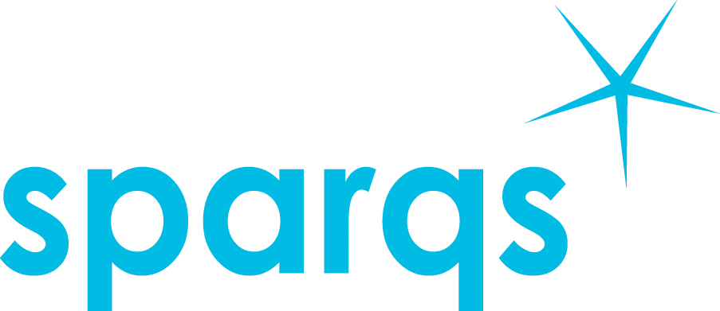

That’s Quality!

23rd September 2014

**Welcome**

Quality enhancement is all about positive change. Whether that be the through the identification of best practice or through the identification of areas that need strengthening by the process of reflection.

Within Scotland we have a world leading approach to quality enhancement, and in particular, student engagement. However, too often students and staff focus on the process rather than the outcome.

This event has been designed to support you to bring about positive change to your students’ learning experience through the use of quality enhancement processes. We have some excellent speakers and facilitators here today which we hope you will take full advantage of their expertise and knowledge.

sparqs will also be here for you throughout the year. Whether that be through delivering tailor made events or through visits and consultancy projects.

We hope you enjoy the event!



**Eve Lewis**

**Director of sparqs**

**Introduction to the event:**

This event has been designed for you to work with your fellow student association colleagues to create learning and teaching objectives for the year ahead and then to understand how the quality enhancement framework can be used to achieve these goals.

You will see this reflected in the aim and objectives below.

**Aim:** To equip you with the knowledge and capability to use the quality enhancement agenda to deliver change for your students’ learning and teaching experience.

**Objectives:** By the end of the day you will:

* Have a better understanding of quality processes.
* Be able to explain the wider quality context.
* Be able to relate this knowledge to your role.

**About your workbook**

The workbook aims to enhance your learning experience by acting as a tool for reviewing your learning. The amount of information that you are able to recall from any learning experience declines drastically within one week of the learning having taken place. It will also enhance your learning, thinking and remembering skills and will increase your knowledge and your confidence. Feel free to make notes all over the place and doodle when you need some thinking space.

By conducting a review of your learning at monthly intervals throughout the year ahead, not only will you be able to transfer this learning into your long term memory, but you will also remind yourself of ideas and aims that you wanted to achieve at the beginning of the year!

**What is ‘Quality’ and why does it matter to your students?**

**Robert Foster, Vice President Education, NUS Scotland**

Your notes:

**What is the Student Learning Experience?  
Mike Williamson, sparqs**

Your notes:

**What is Quality Enhancement and Assurance?**

Your notes:

**Information about sector agencies:**

Sector agencies are organisations which support universities and colleges. They carry out different tasks. The main ones in the university sector are:

* **Scottish Funding Council (SFC)** – distributes the money, implements government policy, ensures that all the institutions are using their funding to further the education they provide.
* **Quality Assurance Agency Scotland (QAA**) – funded by the Scottish Funding Council, is the body that ensures that institutions are providing education that meets academic standards, also responsible for ELIR, and Enhancement Themes.
* **Higher Education Academy (HEA)** – The sector agency for university staff’s professional development. Supports discipline networks and provides consultancy services for institutions.
* **National Union of Students Scotland** – represents the voice of students at university and college, campaigns to make student experience better.
* **Universities Scotland** – represent the principals of universities in Scotland, responsible for lobbying the Scottish Government on national policies.
* **Student Participation in Quality Scotland (sparqs)**

**Task:** Pretend you are the Scottish Funding Council. You want to make sure that the quality of education in universities in Scotland is as high as possible.

What systems and mechanisms might you come up with to make sure quality is as high as it can be? What would you do? Write down some answers and then we’ll compare them to the real system. **Remember what we said about quality assurance and quality enhancement.**

**That’s quality!**

Your notes:

**Tools for change:**

4 Change Quadrants:

Who cares about the change?

What needs to change?

When does the change need to happen?

Who needs to change?

Campaign Chain

* Identify a problem
* Identify solutions to the problem
* Build a campaign team
* Write an effective campaign aim
* Identify the decision maker
* Identify who influences the decision maker
* Map your allies
* Put together your arguments
* Plan your ‘actions’ (lobby, petition, stunt etc)
* Talk to local media
* Thank campaigners
* Communicate wins
* Evaluate

The Impact Chain:

Campaigns are about generating change. We can begin to measure change by thinking about IMPACT.

The traditional way of campaigning is to plan activities and objectives, and when the campaign finishes, try to report the impact of your campaign.

Campaign planning with the impact chain requires you to think at the start about what impact or change you want to achieve through your campaigning objectives then planning your objectives and activities to achieve this impact.

**IMPACT**

(What will change look like? What is your campaign vision/tagline?)

PLANNING PROCESS

CAMPAIGN ‘REAL TTME’

**OUTCOMES**

(What needs to happen to make your change happen?)

**OUTPUTS**

(What activities will generate the necessary changes to happen/what stunts could you run?)

**INPUTS**

(What resources do we need to make these activities/stunts happen?)

sparqs

1, Papermill Wynd

Edinburgh

EH7 4QL

t 0131 622 6599

www.sparqs.ac.uk

by-nc This booklet is licensed under a Creative Commons Attribution Non-commercial 3.0 licence. You are free to copy, communicate and adapt the work, so long as you attribute sparqs. A copy of this licence is available at <http://creativecommons.org/licenses/by-nc/3.0/>

If you require this document supplied in a different format for accessibility, please contact the sparqs office.